

**DESIGN PROJECT REPORT**

**Project Name: Patrolling Bot**

**Supervisors**

Prof. Aparajita Ojha

Prof. V. K. Gupta

Course – Design and Fabrication Project (DS-302)

**Indian Institute of Information Technology, Design**

**and Manufacturing, Jabalpur**

Year: 2021-22

**Team Members**

Ankit Amritesh (2019026)

Siddhant Singh (2019342)

Pratik Tiwari (2019308)

Naman Jain (2019094)

Namesh Dwivedi (2019095)

**Problem Statement**

The lack of a mechanism to track activity near dense forests and jungles. This issue has been ignored for quite some time, and while living in a digital era, we still rely heavily on the same methods used 50 years ago. And the only way to address all these worries is with a surveillance system specifically intended to protect nearby jungle areas.

The primary goal of this project is the development of a surveillance system for use in jungle regions, with the ultimate goal of preventing forest fires and monitoring endangered species.

Therefore, a Patrolling Bot is proposed for this purpose with the goal of reducing both human labour and human error.

**Objective**

1. The goal is to create a security system that will require less human intervention in the monitoring process.
2. It needs to be able to detect unwanted visitors on its own and notify the proper authorities.
3. Give details (such as photos, the exact location, and live video) about the invader.
4. It should function under settings when human performance may suffer (bad weather, dark)
5. It has to have a wide coverage area.

**Embodiment Design**

* The DC motor and belt mechanism of this robot are connected to the Jetson Nano board(B01).
* Components including a chassis, battery, and Wi-Fi module and many other kinds of sensors, such ultrasonic ones Detecting Impediments
* The robot and human will exchange information via the idea behind IoT.
* The robot will utilise the live feed from these cameras to monitor its environment for any unusual activity.
* The robot is programmed to notify the human operator of any problems it detects.

**System Architecture**

* The system is split in two: the user interface and the backend.
* A app for desktop used for sending messages from the human side to the robot side.
* We're making use of the Jetson nano board, which will be featured on the central processing unit and chassis of the robot, This device employs a belt and wheels, which will electrically linked to 12V motors turning at 200 rpm fuel from somewhere else.
* In addition to the sensors already mentioned, the Jetson may also be linked to a wide variety of board's Nano-sized pins

**Physical Architecture**

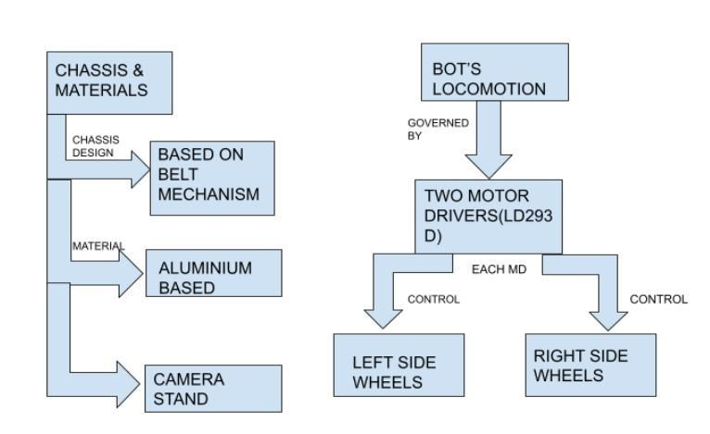

**Why to Use Belt drive over simple wheel drive?**

**Advantage and Disadvantages Of Wheel Mechanism**

| **Advantages** | **Dis-Advantages** |
| --- | --- |
| Simple and inexpensive. | Limited Speed Range |
| Power can be transmitted for a long. | Noncompact. |
| By sliding the belt across a pulley, they prevent machine overloading. | Belt slip affects velocity ratio. |
| Belt drive dampens shock and vibration. | Shafts and bearings are overloaded. |
| Smooth and Silent operation. | Slip and creep cause power loss, reducing efficiency. |
| Durable and low-maintenance. |  |
| High-speed, overload-resistant. |  |

**Belt Material**

Belts are made from materials that have to be durable, while strong and flexible at the same time. A high coefficient of friction ought to be possessed by it. Considering these characteristics we are using Rubber as a material of Belt.

**Belt-drive selection**

These considerations affect belt drive choices.

1. Driver and driven pulley speeds
2. Transmitting Power
3. Midshaft distance
4. Speed Reduction Ratio
5. Positive Drive Requirements

**Why to choose Wood as a Material**

**Tensile Strength:**Although wood is relatively light weight, it has a greater breaking length than steel (or self-support length).

**Resilience to electricity and heat resistance**

When dried to conventional moisture content levels (often between 7 and 12 % for most wood species), wood has a natural impedance to electrical conduction.

**Sound absorption**

The natural acoustical qualities of wood make it a great choice for interior designWood doesn't reflect or enhance noise; rather, it soaks it up.

**Less volatile organic compounds are released from wood.**

Wood, a renewable resource, out gases less carbon dioxide and volatile organic compounds (VOCs) than metals, man-made composites, and plastics.

**Wood Is A Natural Insulator**

Due to its cellular structure containing air spaces, wood is an effective insulator. Wood is a superior insulation to masonry and concrete (15 times better), steel (400 times better), and aluminium (1,770 times better).

**CAD MODEL Images**

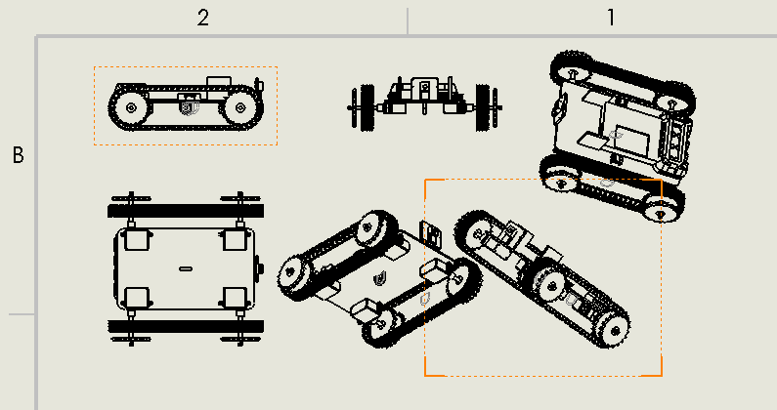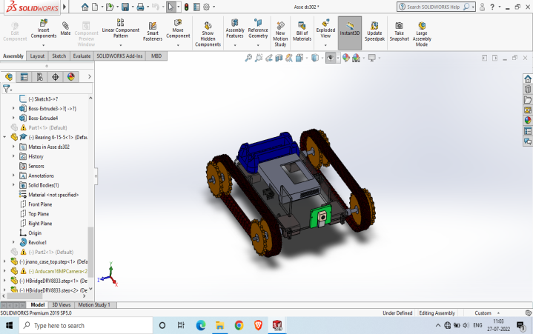

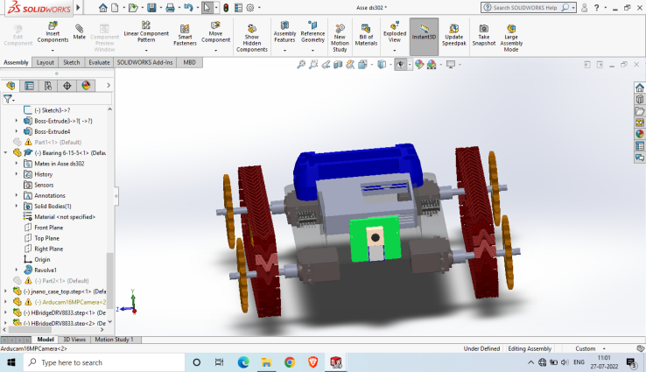

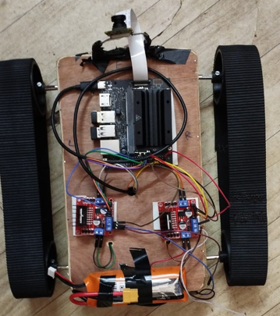

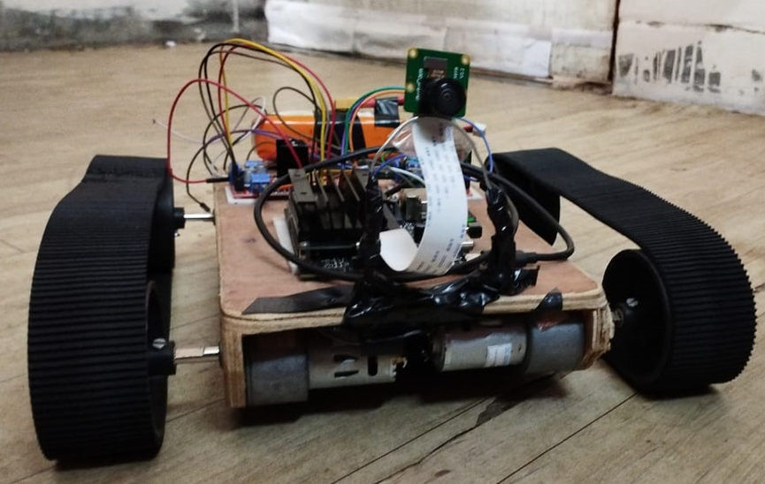

**Object Detection Algorithms:**

* Object detection can be done with computer vision algorithms.There are different ways for computer vision to be built to work with pictures.
* The way the neurons are set up in these architectures is different,how layers are stacked, what kinds of layers are used, etc. We need structures that can find things (mainly) live camera feeds of people
* Make use of a Convolutional network to identify objects in real-time video.
* Video frames are read using OpenCV's image processing.
* video object detection using YOLOv3-tiny architecture based on COCO dataset
* Possesses the ability to identify 80 distinct types of items
* The video stream is sent to the user through the flask framework.

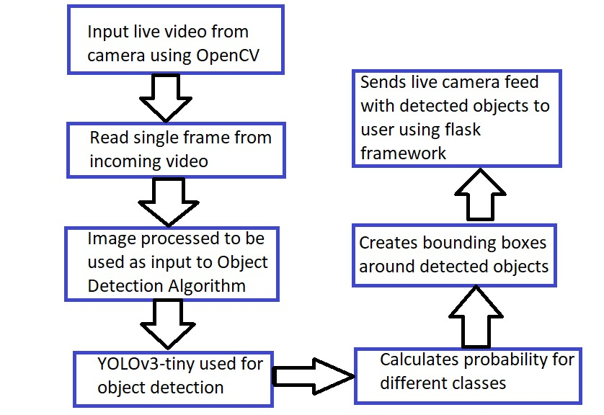

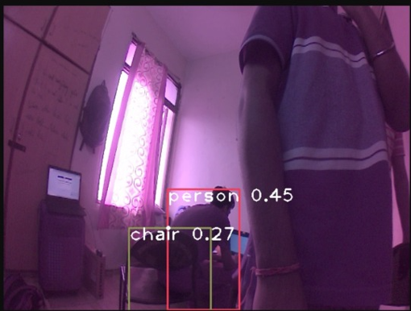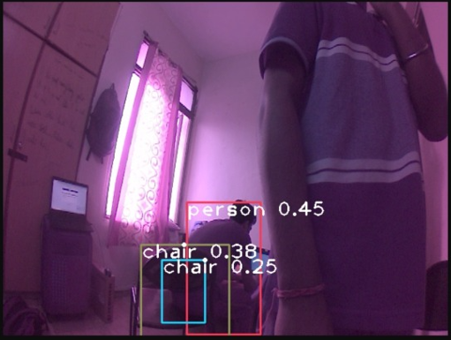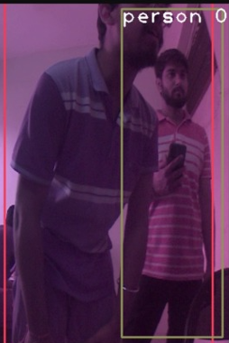

**Future Aspects**

Most computer and robot vision systems involve object detection. Object identification involves finding the location and size of all object instances in a picture. Recent research has made considerable strides in several aspects. Object detectors discover all instances of provided object classes independent of scale, position, posture, camera view, partial occlusions, and lighting conditions.

Object detection is used in HCI, robotics (e.g., service robots), consumer electronics (e.g., smart-phones), security (e.g., recognition, tracking), retrieval (e.g., search engines, photo management), and transportation (e.g., autonomous and assisted driving). Each application has varied processing time (off-line, on-line, or real-time), occlusion robustness, rotation invariance (e.g., in-plane rotations), and posture change detection requirements.

**Novelty**

This Surveillance Patrolling Bot project’s novelty is that it can provide us with the live video feed along with detecting the objects and beings with the camera situated in the bot’s front. This kind of surveillance is new in the field of jungle surveillance as it can provide the forest security with important feed which can help in solving the different kind of situation that frequently arises in rural areas nearby jungles or vegetation filled areas.

**Specific Contribution of Each member**

**Siddhant:** 1. Setting up Jetson nano 2. Development of code for processing live camera feed 2. Object Detection using CNN 3. Configuring GPIO pins in jetson-nano 4. Code for motion of bot

**Naman:** Designing and fabricating a jungle surveillance Bot ,I was responsible for designing CAD model for our project and Responsible for designing and fabricating chassis and to integrate motor with motor drivers and battery.

**Namesh:**Object Detection using CNN . Responsible for designing and fabricating chassis and to integrate motor with motor drivers and battery and implementation of basic motion of bot.

**Pratik:** the circuit work, including linking to Jetson Nano, has been completed by him.He contributed to the bot's assembly and Involved in writing code for the system that detects objects

**Ankit:** helped with object detection code, and Did the connection of motors and motor driver and jetson nano through GPIO pins and jumper wires, Along with the code of GPIO pins of bot movability

**Summary**

* We tried to find a better, more modern way to do surveillance, which has been done mostly by hand up until now.
* Here, we tried to make a model for a robot that keeps an eye on things. It uses ideas from IoT and computer vision to keep an eye on a small area.
* This solution can be very helpful in many ways to reduce the amount of work and labour needed to do surveillance tasks.